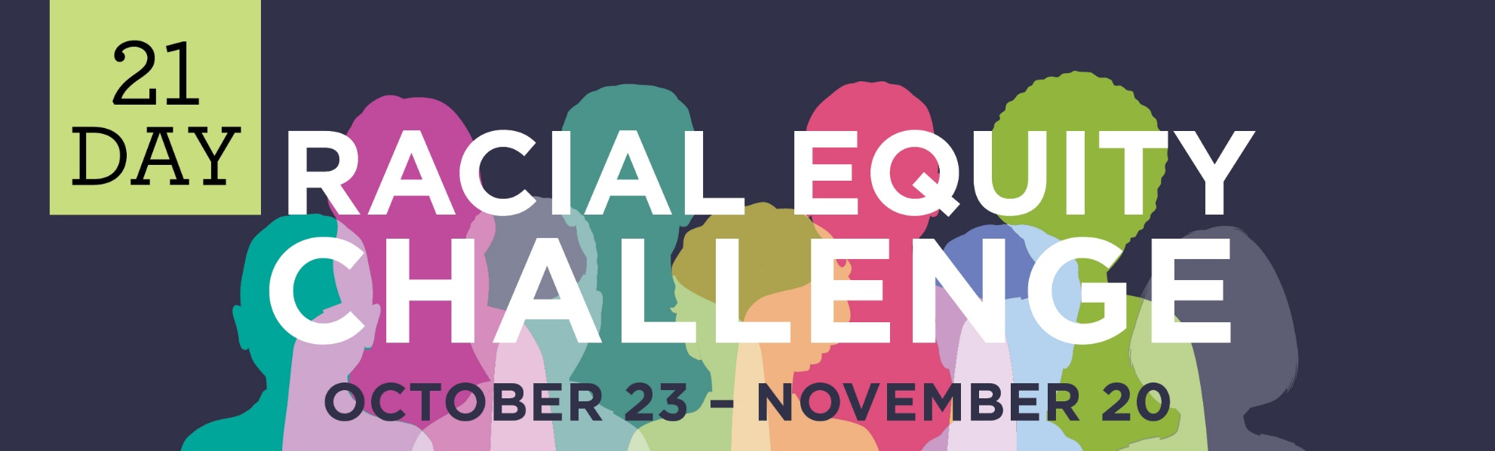
COMPANY NAME team,

By now you may have heard that thousands of individuals and hundreds of local organizations have joined together to take a community-wide 21-Day Racial Equity Challenge. The Challenge is a powerful opportunity to collectively develop a deeper understanding of how inequity and racism affect our lives and community. COMPANY NAME is dedicated to learning and taking action to create an equitable community for all, and has chosen to participate in the 21-Day Racial Equity Challenge.

WHAT THIS MEANS FOR YOU
Option 1
Each weekday from October 23 – November 20 you will receive an email from info@ROCequitychallenge.org with articles, podcasts and videos to learn about racism and equity, suggestions for reflection and options to continue your learning or take action. Our company will also offer [a lunch and learn during the Challenge to allow for employee discussion, a company town hall/department meeting time to reflect on your learnings as a team, the opportunity to join an internal team to begin /continue reviewing our organization’s policies and practices to examine how we can ensure equity remains a focus.]

Option 2
Each weekday from October 23 – November 20 you will receive an email from EMPLOYEE NAME, who will forward articles, podcasts and videos from Rochester’s 21-Day Racial Equity Challenge. These emails will provide opportunities for self-guided learning, offer suggestions for reflection and options to continue your learning or take action. Our company will also offer [a lunch and learn during the Challenge to allow for employee discussion, a company town hall/department meeting time to reflect on your learnings as a team, begin/continue reviewing our organization’s policies and practices to examine how we can ensure equity remains a focus.]

Option 3
We encourage you to visit www.ROCequitychallenge.org to sign up for the Challenge. After you sign up, each weekday from October 23 – November 20, you will receive an email from info@ROCequitychallenge.org with articles, podcasts and videos that will provide opportunities to develop a deeper understanding of how racism and inequity affect our lives and community , offer suggestions for reflection and options to continue your learning or take action. Our company will also offer [a lunch and learn during the Challenge to allow for employee discussion, a company town hall/department meeting time to reflect on your learnings as a team, begin/continue reviewing our organization’s policies and practices to examine how we can ensure equity remains a focus.]

Thank you for standing with COMPANY NAME to confront racism, bias and other social injustices to create a just and equitable community for all.

